ALPINE AEROTECH LTD.

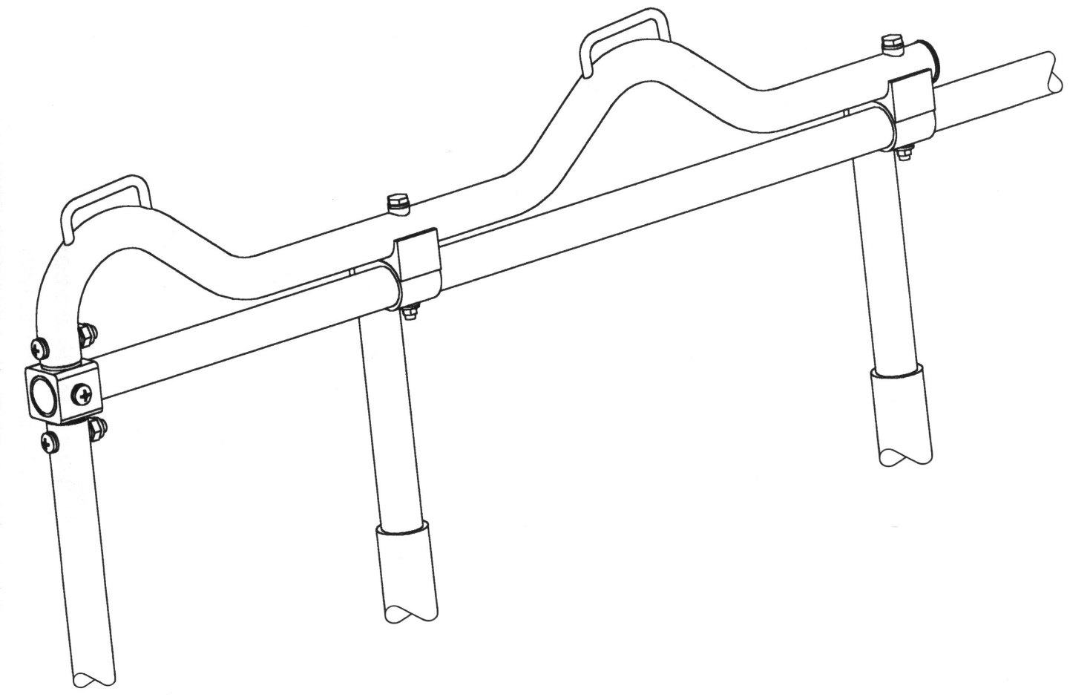

SHOULDER HARNESS KIT
INSTALLATION INSTRUCTIONS

MODELS: BELL 212/412
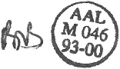

Read all of the instructions thoroughly prior to the installation of this product.

Revision: H
Date: 2023-05-12 Doc. No.: 191M-99-001-II Page 1 of 15
ALPINE AEROTECH LTD.
INSPECTION

Refer to the Shoulder Harness Kit Maintenance Manual Supplement, Models: BELL 212/412. Document No.: 191M-99-001-MMS

APPLICABILITY

- MODEL: BELL HELICOPTER 212, 412, 412EP
SERIAL NO.: ALL

Shoulder Harness Kit - SH99-220 is only applicable to standard passenger utility seats (non-crash-attenuating).

WEIGHT & BALANCE

Part Number Description Weight Long. Arm Lat. Arm
(Lbs.) (Inches) (Inches)

AAL-370-711-001 Complete Kit 33.76* 115.83 0.00

AAL-370-711-003 Front 9 Kit 25.81* 108.74 0.00

AAL-370-711-004 Back 9 Kit 24.55* 131.22 0.00

AAL-370-711-011 2 Person LHS Seat Kit 3.97* 138.86 15.72 (LBL)

AAL-370-711-012 2 Person RHS Seat Kit 3.97* 138.86 15.72 (RBL)

AAL-370-711-015 5 Person Seat Kit 16.60* 127.56 0.00

AAL-370-711-016 4 Person Seat Kit 9.21* 74.80 0.00

* Weight excludes new lap belts

INSTALLATION NOTES

1) All instructions, where applicable, are to be completed using standard aircraft sheet metal and maintenance practices.
2) All hardware must be torqued to standard specs.
3) Reference numbers in installation correspond to dash numbers on Parts List.
1
Install Button Plug (Item 154) with Loctite 401 Prism Adhesive.

Revision: H
Date: 2023-05-12 Doc. No.: 191M-99-001-II Page 2 of 15

INSTALLATION, SECTION A

2 PERSON OUTBOARD FACING SEATS

1) Unbutton the top half of the soundproofing blankets or remove the deluxe interior plastic panels on the vertical side walls of the pylon.

- Remove the necessary bolts retaining the upper, side pylon inspection panels and install the bracket assemblies, -031 LHS FWD/-032 RHS FWD and -035 LHS AFT/-036 RHS AFT, and hardware as shown. Reference Figure 1.

Revision: H
Date: 2023-05-12 Doc. No.: 191M-99-001-II Page 3 of 15
ALPINE AEROTECH LTD.

LHS SHOWN, RHS OPPOSITE

FIGURE 1

3) Cut ¾” dia. holes in the soundproofing blankets, 4 places per side, and sew the edges as required or cut ½” x 2 3/8” slots with 3/8” corner radii in the deluxe interior plastic panels, 2 places per side. Cut the holes in the same locations as the mounting holes for the inertia reels and belt guide assemblies as shown. Reference Figure 1&2.

4) Install the plastic belt guides, -134, into the deluxe interior plastic panels with Loctite 401 Prism adhesive as required. Reference Figure 2.

5) Reinstall the soundproofing blankets only.

6) Install the inertia reels, -131, belt guide assemblies, -044, and hardware as shown. Install the hardware with Loctite 243 threadlocker as required. Reference Figure 3&4.

7) Place the webbing from the inertia reels through the belt guide assemblies, -044, as shown and install the hardware. Apply Anti-Tamper/Witness Paint to the hardware and guide frame as shown. Reference Figure 5.

Revision: H
Date: 2023-05-12 Doc. No.: 191M-99-001-II Page 4 of 15
ALPINE AEROTECH LTD.

TYP PLASTIC BELT GUIDE INSTALLATION TYP REEL INSTALLATION
FIGURE 2 FIGURE 3

TYP GUIDE INSTALLATION TYP GUIDE ASSEMBLY
FIGURE 4 FIGURE 5

Revision: H
Date: 2023-05-12 Doc. No.: 191M-99-001-II Page 5 of 15
ALPINE AEROTECH LTD.

8) Reinstall the deluxe interior plastic panels and lead the webbing through the plastic belt guides, -134, as shown. Reference Figure 2.

9) Remove the existing lap belts and install the new lap belt buckle halves, -129, connector halves, -128, and shoulder harness straps as shown. Reference Figure 6&7.

LHS SHOWN, RHS OPPOSITE

FIGURE 6

Revision: H
Date: 2023-05-12 Doc. No.: 191M-99-001-II Page 6 of 15
ALPINE AEROTECH LTD.

TYP BELT INSTALLATION

FIGURE 7

10) Install the cotter pins, -130, into the hook ends, 4 places per side, of the lap belts. Reference Figure 8.

TYP COTTER PIN INSTALLATION

FIGURE 8

INSTALLATION, SECTION B

5 PERSON FWD FACING SEATS

1) Remove the soundproofing blanket or the deluxe interior plastic panel on the vertical FWD wall of the pylon.

2) Remove the two (2) rivets at the intersections of WL 63.93, LBL 6.76 and WL 63.93, RBL 6.76 on the FWD wall of the pylon as shown. Reference Figure 9.

NOTE: Be careful not to damage any hardware or hydraulic lines on the backside of the wall when removing the rivets.

Revision: H
Date: 2023-05-12 Doc. No.: 191M-99-001-II Page 7 of 15
ALPINE AEROTECH LTD.

FIGURE 9

3) Place the doublers, -112, on the backside of the wall and transfer the rivet hole locations into each doubler as shown. Open up the holes in the wall and doublers to .203” dia. (13/64). Reference Figure 9&10.

NOTE: Access for this operation can be easily obtained through the lower, side pylon inspection panels. Reference Figure 6.

Revision: H
Date: 2023-05-12 Doc. No.: 191M-99-001-II Page 8 of 15
ALPINE AEROTECH LTD.

LHS SHOWN, RHS OPPOSITE

FIGURE 10

Revision: H
Date: 2023-06-24 Doc. No.: 191M-99-001-II Page 9 of 15
ALPINE AEROTECH LTD.

4) Install the bracket assemblies, -039 LHS/-040 RHS, and spot the rivet hole locations from the wall into the brackets as shown. Remove the brackets and drill the holes through, .203” dia. (13/64). Drill the holes 90 degrees to the face of the brackets. This operation should be performed on a drill press. Reference Figure 9,10,11.

NOTE: The rubber padding surrounding the hi-loks on the fwd pylon wall may require trimming to install the bracket assemblies.

5) Apply anticorrosion primer to the insides of the previously drilled holes in the bracket assemblies, -039/-040, doublers, -112, and FWD wall of the pylon.

TYP BOLT INSTALLATION

FIGURE 11

6) Reinstall the bracket assemblies and hardware as shown. Install -141 with Loctite 243 threadlocker as required. Reference Figure 9,10,11.

7) Cut ¾” dia. holes in the soundproofing blankets, 4 places per side, and sew the edges as required or cut ½” x 2 3/8” slots with 3/8” corner radii in the deluxe interior plastic panel, 3 places. Cut the holes in the same locations as the mounting holes for the inertia reels and belt guide assemblies as shown. Reference Figure 9&2.

8) Install the plastic belt guides, -134, into the deluxe interior plastic panel with Loctite 401 Prism adhesive as required. Reference Figure 2.

9) Reinstall the soundproofing blankets only.

10) Install the inertia reels, -131, belt guide assemblies, -044, and hardware as shown. Install the hardware with Loctite 243 threadlocker as required. Reference Figure 3&4.

11) Place the webbing from the inertia reels through the belt guides assemblies, -044, as shown and install the hardware. Apply Anti-Tamper/Witness Paint to the hardware and guide frame as shown. Reference Figure 5.

12) Reinstall the deluxe interior plastic panel and lead the webbing through the plastic belt guides, -134, as shown. Reference Figure 2.

Revision: H
Date: 2023-05-12 Doc. No.: 191M-99-001-II Page 10 of 15
ALPINE AEROTECH LTD.

13) Remove the necessary hardware from the stanchion posts and install the stanchion post collar assemblies, -041, hardware, and inertia reels, -131 as shown. Install -140 with Loctite 243 threadlocker as required. Reference Figure 12&13.

LHS SHOWN, RHS OPPOSITE

FIGURE 12 FIGURE 13

14) Remove the existing lap belts and Install the new lap belt buckle halves, -129, connector halves, -128, and shoulder harness straps as shown. Reference Figure 7&14.

Revision: H
Date: 2023-05-12 Doc. No.: 191M-99-001-II Page 11 of 15
ALPINE AEROTECH LTD.

FIGURE 14

15) Install the cotter pins, -130, into the hook ends, 10 places, of the lap belts. Reference Figure 8.

Revision: H
Date: 2023-05-12 Doc. No.: 191M-99-001-II Page 12 of 15
ALPINE AEROTECH LTD.

INSTALLATION, SECTION C

4 PERSON AFT FACING SEATS

1) Remove the hardware from the lap belt I-bolts and install the reel brackets, -119 OUTBD/-120 INBD, hardware, and inertia reels, -132, as shown. Reference Figure 15.

TYP REEL INSTALLATION

FIGURE 15

2) Remove the headrests and necessary hardware from the seat and install the support tube connectors, -117, support tube saddles, -118, tube assemblies, -042, and hardware as shown. Reinstall the headrests. Reference Figure 16 and isometric drawing on cover page.

Revision: H
Date: 2023-05-12 Doc. No.: 191M-99-001-II Page 13 of 15
ALPINE AEROTECH LTD.

1

LHS SHOWN, RHS OPPOSITE

FIGURE 16

Revision: H
Date: 2023-05-12 Doc. No.: 191M-99-001-II Page 14 of 15
ALPINE AEROTECH LTD.

3) Remove the existing lap belts and Install the new lap belt buckle halves, -157, connector halves, -156, and shoulder harness straps as shown. Reference Figure 7&17.

FIGURE 17

4) Install the cotter pins, -130, into the hook ends, 8 places, of the lap belts. Reference Figure 8.

Revision: H
Date: 2023-05-12 Doc. No.: 191M-99-001-II Page 15 of 15

